SASOL Chemicals (USA) LLC Document No.• L2CC-030-70-EN-5500

# Lake Charles Chemicals Project (LCCP) Rev: 5

Contract: L2CC Page 31 of 79

FLUOR Sasol

reaching new frontiers

# PROCESS CONTROL NARRATIVE - SECTION 5500 ALCOHOL PREPARATION

## 4.3.7Recycle Butanol

Reference P&lDs: L2CC-030-25-P1-5526, L2CC-030-25-P1-5532, L2CC-030-25-P1-5533, L2CC-030-25PI-9060-02, L2CC-006-25-P1-9067, LCCC-074.9-P1-144

Recycle butanol is introduced into the system to remove C6+ Alcohol from the slurry stream. C2 and C4 alcohols are removed in the butanol stripper. Recycle butanol flow controller (FC53215) receives its setpoint from a ratio (FFC53215) of recycle butanol flow rate (FC53215) to slurry from the hydrolysis reactor (FC53201). FFC53215 shall not use SP-PV tracking.

The M-value of the stripped alkoxide and the use of TAP significantly affect how many units of alumina are produced per unit of water reacted per unit of stripped alkoxide. As more alumina slurry is produced, more extraction butanol is required. Lower M values and TAP production both result in more alumina production. To compensate for this, feedback ratio controller (FFC53201) adjusts the SP ofFFC53215 according to the ratio of recycle butanol flow to slurry feed to the Butanol Stripper. The PV equation follows:

|  |  |
| --- | --- |
| FC53201 — - 4-hour rolling average of FC53201. PV  FC53215 - 4-hour rolling average of FC53215. PV  FFC53201.PV = FC53215/FC53201 | (sampled at 10-second intervals)  (sampled at 10-second intervals)  (in LB/LB) |

FFC53201 uses a normal PID algorithm with very low gain and long integral time for its tuning. The SP for FFC53201 shall be changed only by the engineer. Initial value for SP is 0.655, based on HMB data. FFC53201 shall not use SP-PV tracking.

The recycle butanol flow measurement, along with the C2 tower bottoms flow, is used as a feedforward signal for the existing recycle butanol level controller (LC90106), pure butanol to FB-552. LC90106 must be modified to function within the control strategy described here. For details, see Appendix Il.

Device XV91104 allows operators to open up an automated condensate valve XV-91104, which puts metered (via a rotameter) condensate to the suction of the S-5500 recycle butanol pumps. This is done occasionally since too low a water content in recycle butanol can cause problems in the extraction section. When recycle butanol flow falls below a pre-determined value, a DCS interlock closes automated valve XV-91104 so that the recycle butanol does not become too diluted with water. Only Manual operator interaction from the DCS can open the valve.

When operating in TAP production mode, the operator selects FC53201 to ratio with butanol. When operating in normal production, he selects FC53130 to ratio with butanol. The setpoint of FFC53215 needs to change based on the position ofHS53215.

If T030-5502 is functioning as recycle butanol tank, XV91103 can be used to open XV-91103 and put metered demin water into the suction of -5500 recycle butanol pumps.

L2CC-030-70-EN-5500 REV 5. DOCX [Control Systems]

SASOL Chemicals (USA) LLC Document No.• L2CC-030-70-EN-5500

Lake Charles Chemicals Project (LCCP) Rev: 5

## FLUOR

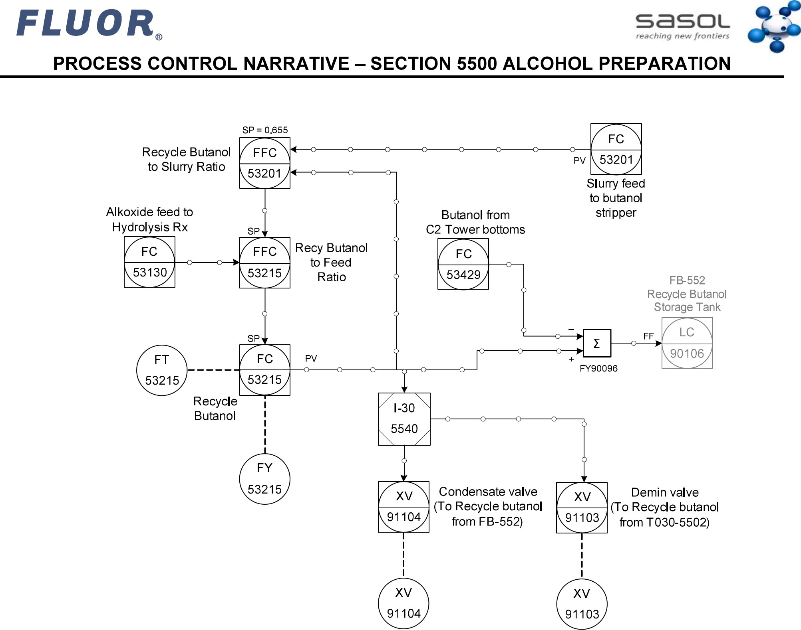

Contract:

L2CC

Page

32

of

79

Demin valve

(To Recycle butanol from T030-5502)

L2CC-030-70-EN-5500 REV 5. DOCX [Control Systems]